Green Competences in Hotel and Restaurant
Why exemption from the reporting obligation simplifies nothing
Let us begin with the good news that owners of small tourism properties have been waiting two years for: you most probably do not have to report ESG.
Since 18 March 2026, following the entry into force of the EU’s Omnibus I package, the sustainability-reporting obligation applies only to enterprises employing at least a thousand people and with a turnover above 450 million euro. It is estimated that about eighty per cent of the bodies that only a year earlier were preparing to report have fallen outside the scope of the obligation. For a Polish hotel with thirty rooms or a restaurant employing twelve people, the matter is closed before it opened. And now the worse news: this simplifies nothing.
What has changed is not the level of expectation towards the industry, but the party enforcing it. The regulator has eased off. The market has not. And it is worth understanding why the market is demanding in a different way here, but no less so.
What exactly changed
It is worth spending a moment on the mechanics, because the whole of what follows depends on them.
The Omnibus I package, implemented by Directive (EU) 2026/470, raised the thresholds of the CSRD and at the same time introduced an instrument that matters more for small firms than the exemption itself: a limit on requests within the value chain. A large enterprise subject to the reporting obligation may not demand from a smaller business partner data going beyond the scope of the simplified VSME standard developed by EFRAG. A body employing fewer than a thousand people has the right to refuse — and that refusal has a legal basis.
This solution curbed a phenomenon that in 2024–2025 became the bane of suppliers: multi-page ESG questionnaires, each in a different format, each justified by “the contractor’s reporting requirements,” each demanding data a small firm had never collected. The VSME standard now serves a double function — a voluntary reporting model for firms outside the scope of the CSRD, and a legal limit on information requests. The key word, however, is voluntary. Not “redundant.”
Where the pressure has moved
If not the regulator, then who? There are three channels, all real for a property operating in a Polish tourism region.
The first channel — B2B partners. A tour operator, a travel agency, a company organising team-building trips, a corporation booking a conference. These bodies are either themselves subject to the CSRD, or have their own procurement policies, or answer to their own clients. All of them will ask about environmental practices — not because they must, but because that is what today’s market standard looks like. The difference is that they may now ask only within the scope of VSME. Which, paradoxically, makes things easier: it is clear what to prepare for, and clear where the line runs.
The second channel — reservation platforms. This is the most important and most underestimated mechanism. According to Booking.com’s report on tourism and sustainability, in 2025 a hundred million nights were booked on this single platform in properties holding a sustainability certificate issued by an independent body. More than a third of travellers in every age group — from Generation Z to the post-war baby boom, in each case about thirty-five per cent — declare an intention to use such a property within the coming year. This is no longer a generational or niche phenomenon.
The third channel — financing. Banks and support institutions increasingly differentiate their terms according to the environmental profile of a venture. In an investment to modernise a property, this translates directly into the cost of capital — that is, into a bill the owner sees every month.
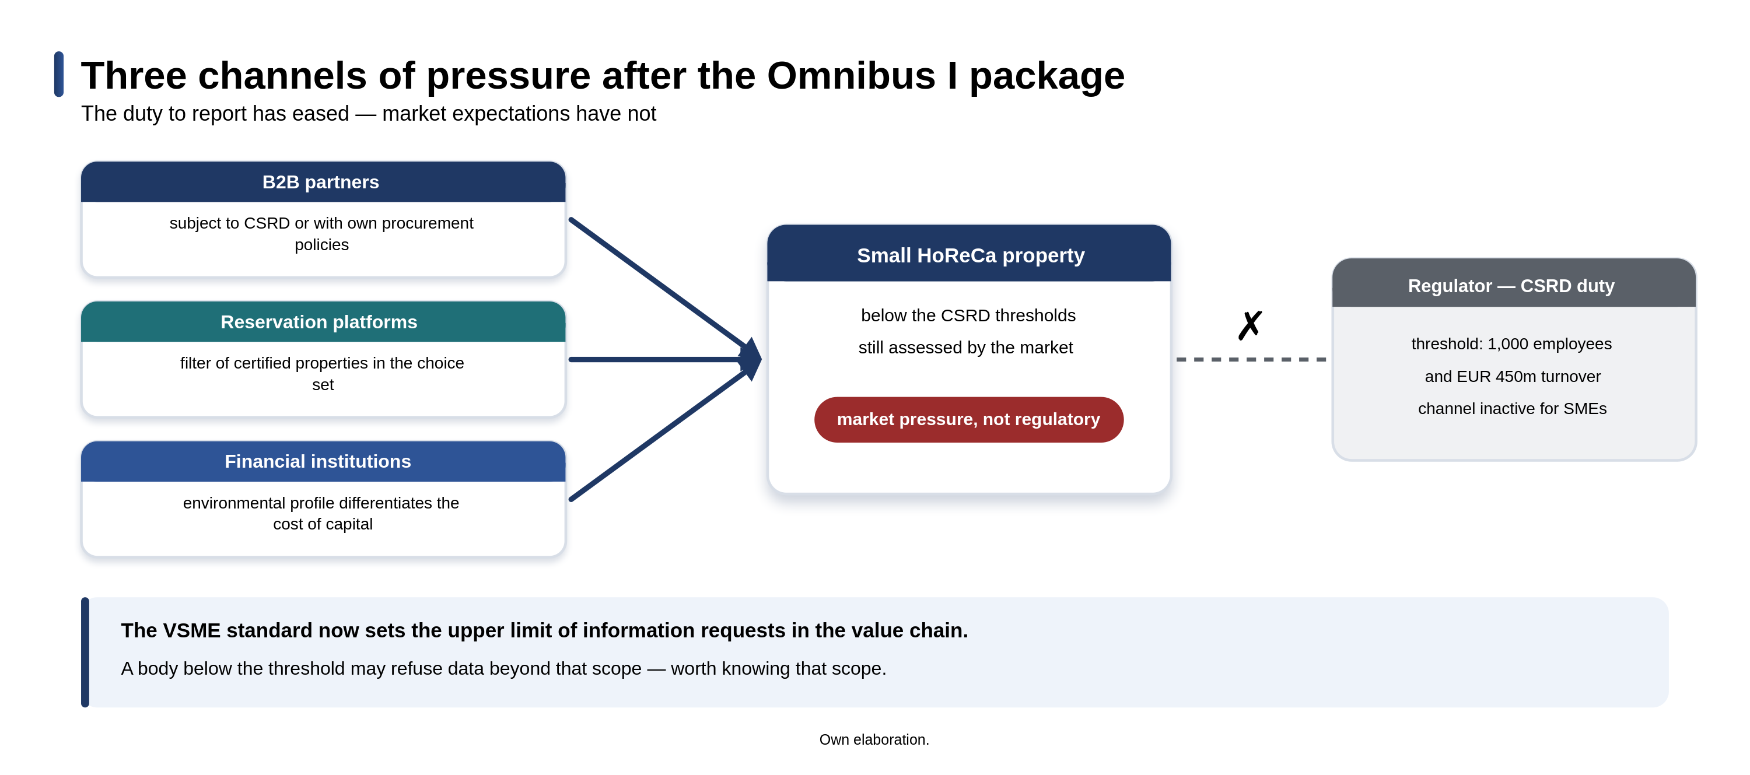
Figure 1. Three channels of pressure after the Omnibus I package. Own elaboration.
The certificate: what it means in practice
Here one must say something that sounds less impressive than industry marketing, but is closer to the truth.
A sustainability certificate is not a tool for raising prices. It is, first and foremost, a tool of visibility.
Let us begin with what the literature says, because the picture here is more interesting than either side of the dispute suggests. Studies of eco-labelling in tourism report price premiums across a very wide range — from a dozen or so to several dozen per cent, depending on the region, the type of label and the degree of consumer trust.
Sipic (2017) measured the premium associated with the Blue Flag on the Croatian coast; Janjušević and Perović (2020) analysed eco-certification in Montenegrin tourism. De la Ballina, Valdés and Del Valle (2020), applying signalling theory directly, demonstrated a link between quality standards and hotel performance, pointing to gains in labour productivity and competitive position. Consumer research, however, gives a more restrained picture. Between 43 and 50 per cent of travellers declare a willingness to pay more for a stay in an eco-friendly property, but the premium actually accepted is usually 5 to 10 per cent. At the same time, more than half of respondents admit that price is what mainly decides their choice, and only a few to a dozen or so per cent name sustainability as the most important criterion. Where does this discrepancy come from — between tens of per cent in the pricing studies and five per cent in consumer declarations? The answer is instructive. The high premiums measured in the literature come largely from a selection effect: certified properties are usually also better managed, better equipped and better located. The certificate does not so much create the premium as accompany the features that create it. And the gap between declaration and behaviour is, in this field, a durable and well-documented phenomenon — we declare values, we pay according to our wallet. Whence, then, the hundred million nights?
From the fact that a certificate works like a filter, not a price tag. A guest entering their search criteria ticks the “sustainable property” option and from that moment sees only certified properties. They do not pay more — they simply do not see the rest at all. The certificate does not so much raise the margin as decide presence in the choice set. And a property that is not in the choice set does not compete on price, because it does not compete at all.
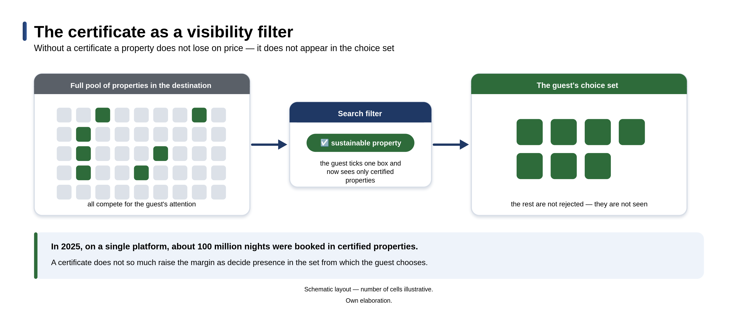
Figure 2. The certificate as a visibility filter. Own elaboration.
Economics has known this mechanism for half a century and calls it signalling (Spence, 1973). The buyer cannot judge quality before purchase — they cannot, after all, check before booking whether a hotel really sorts its waste, where it gets its vegetables, and what it does with uneaten food. They must therefore rely on signals: certificates, quality marks, confirmations issued by a third party. In a situation where the regulator has stopped requiring reporting, the certificate remains the only credible carrier of information about a property’s actual practices. Its significance after Omnibus has not fallen. It has risen. Honesty, however, requires adding two caveats. First, online reviews often have a stronger influence on booking decisions than certificates — consumers trust another guest’s account more than an institution’s attestation. Second, the proliferation of labels causes confusion and weakens the force of each of them individually. The practical conclusion: better to obtain one recognisable certificate than three niche ones, and best of all to have both signals at once — the certificate that gets you into the choice set, and the reviews that win within it.
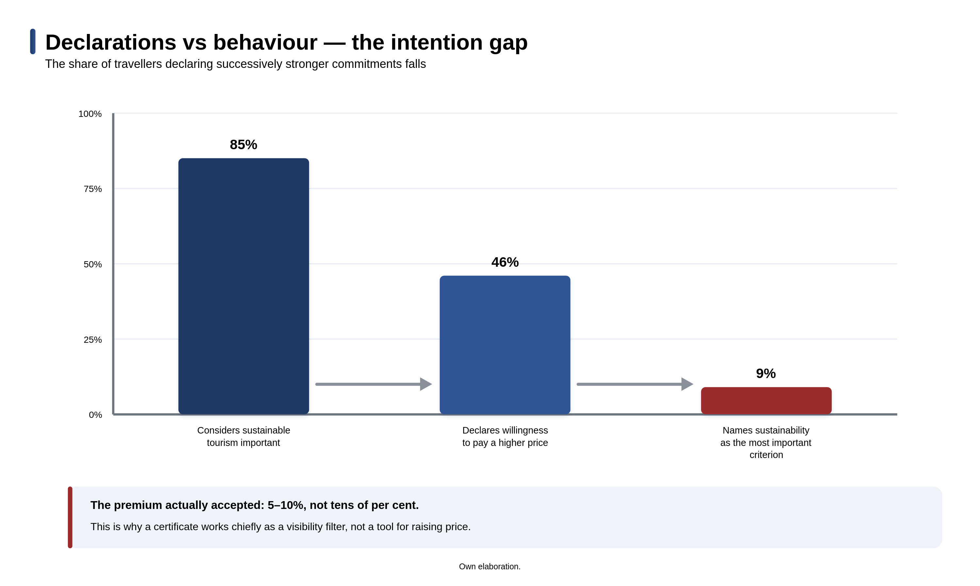
Figure 3. Declarations vs behaviour — the intention gap. Own elaboration.
The opposite risk
There is also the other side of this coin, and disregarding it can be costly. A declaration not backed by practice is greenwashing — and detecting greenwashing is today far easier and far more painful than a few years ago. A guest who read on the website about “care for the environment” and then, at breakfast, saw single-use packaging, plastic straws and full bins of uneaten food will not write a complaint. They will write a review. And a review outlasts a season and lands exactly where trust carries the most weight. This is why the order should be the reverse of what marketing intuition suggests: first practice and competence, then communication, and last of all the certificate. A certificate that runs ahead of real changes in the property is a commitment that cannot be met — and a commitment unmet does more harm than its absence.
Who is actually to do this
And here we come to the question that is asked least often in conversations about ESG in small firms, and which is the decisive one. Sustainability in a hotel and a restaurant does not happen at the level of strategy. It happens daily, at the level of the workstation. The cook deciding on portion size and how to use leftovers. The housekeeper running a wash of towels the guest did not leave on the floor. The shift manager switching on the air conditioning in an unused conference room. The buyer choosing between a supplier from the neighbouring commune and a wholesaler two hundred kilometres away. The sum of these daily decisions is the property’s real environmental footprint — not an entry in the company policy and not a declaration on the website.
This means that environmental competences are employee competences, and managing them is a task in the field of human-resource management, not environmental protection. The literature calls this area green human-resource management and speaks of it fairly unambiguously. Aboramadan and co-authors (2022) show that hotel employees’ pro-environmental behaviours depend above all on leadership style and perceived organisational support — not on the availability of technology or provisions in the regulations. Khatter and co-authors (2021), studying the barriers to and drivers of sustainability in Australian hotels, identify low managerial engagement and resistance to change as obstacles more severe than cost. The practical conclusion is twofold. A procedure the team does not understand will not be implemented — it will become a dead letter. And a certificate whose maintenance requires systematic measurement and documentation will fall apart at the first major turnover of staff if the knowledge sat in one person’s head. In an industry with turnover reaching, by some studies, 30 to 70 per cent a year, this is not a theoretical risk. Tokarz-Kocik and co-authors (2023), analysing the Polish labour market in the hotel industry, point to its structural instability as a durable feature, not a consequence of the pandemic. Polish research suggests a solution here that the industry usually overlooks. Radlińska and Gardziejewska (2022) showed that 75.6 per cent of the Polish tourism enterprises surveyed use a labour-hoarding strategy — keeping staff on outside the season despite the lack of work, in order to secure the workforce for the peak. It is a costly decision, but a rational one given the staff shortage. It has, however, a consequence worth using: since we are paying to keep the team on in the low-occupancy months anyway, the off-season is a natural training window at almost zero opportunity cost. The “we have no time” barrier, which in research on small tourism firms appears right after the cost barrier, thus turns out in Polish conditions to be partly illusory. The time is there, it is simply not used.
It is also worth noticing a relationship running the other way. For some candidates — especially younger ones — the way a firm treats environmental and social matters is part of how they assess an employer. Marcinkowska and Sawicka (2023), studying Polish small and medium-sized enterprises, showed that corporate-social-responsibility activities are noticed by employees and influence their employment decisions. In a sector recording an average staff shortage of around ten per cent in Europe (HOTREC, 2026), credible sustainable practice ceases to be merely a cost and becomes a recruitment argument. Green competences help not only to win a guest, but also to keep an employee.
Four steps to start
First, measure before you declare. Energy and water consumption and the volume of waste over a year, per guest-night or per meal served. Without this basis, every further conversation — with a certifier, a contractor or a guest — is a conversation about impressions. Measurement costs a few hours a month and requires no investment.
Second, start by eliminating food waste. In catering, this is the area where the environmental and financial effects go together most closely. Cutting losses lowers the cost of ingredients immediately, the result is easily measurable, and the team sees the point of the action without having to be won over to the idea. It is the best possible starting point, because it builds credibility inside the firm.
Third, get to know VSME. Not in order to report, but in order to know what a contractor has the right to ask about — and what it may not. Knowing your own limits in a negotiation has measurable value, and the reading takes one afternoon.
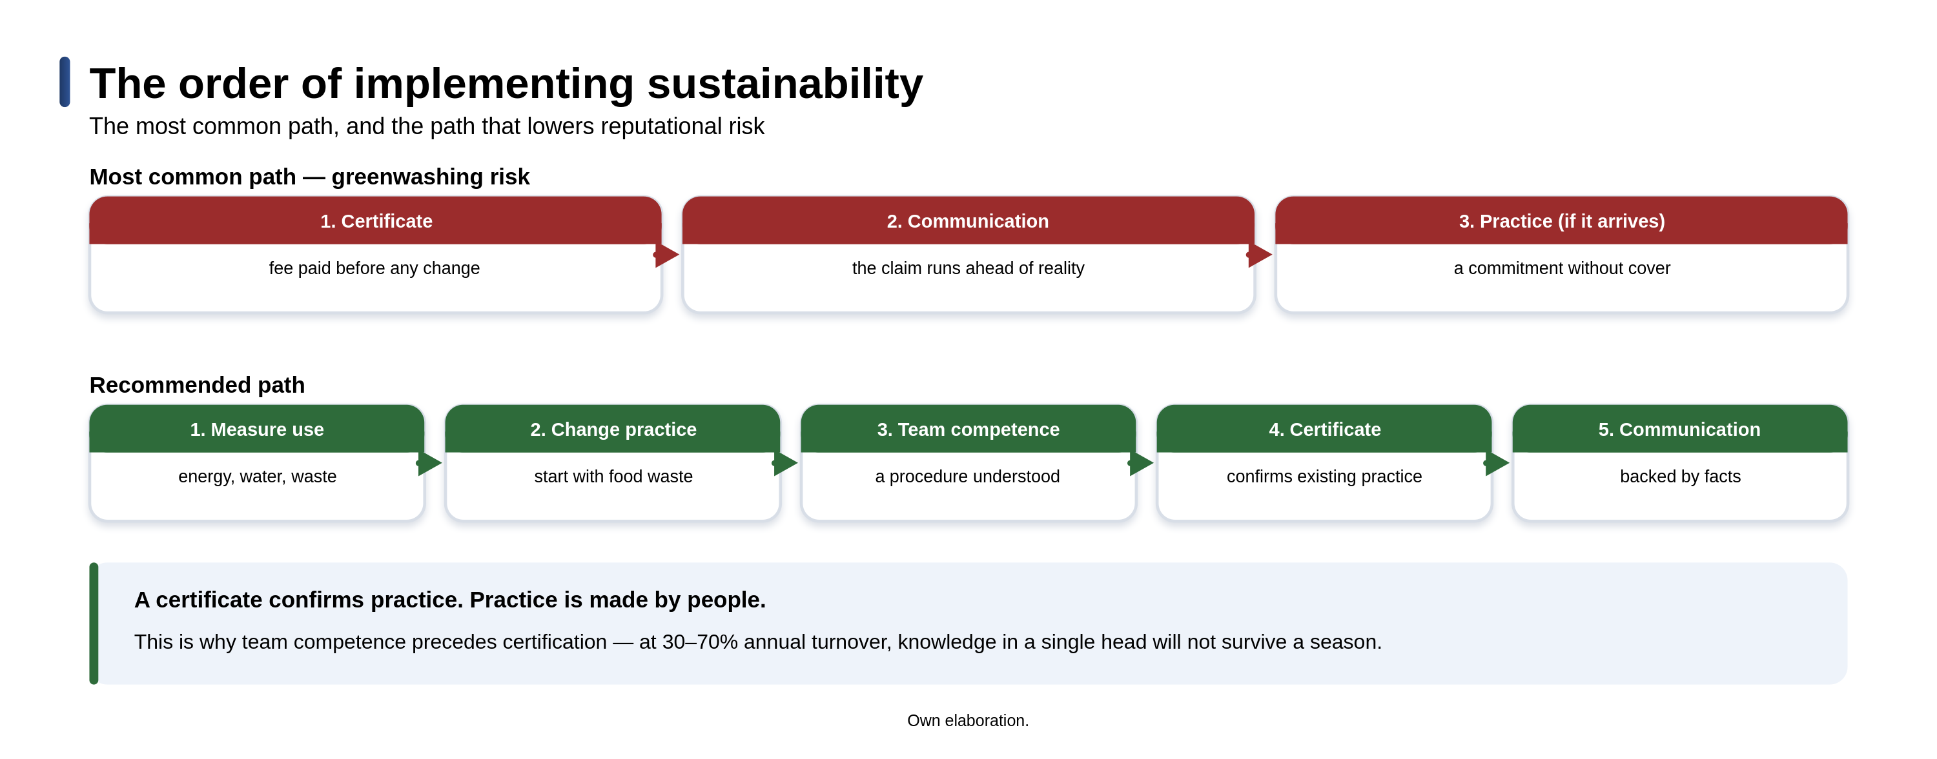
Figure 4. The order of implementation — wrong and recommended. Own elaboration.
Fourth, train the team before applying for a certificate. A certificate confirms practice, and practice is made by people. Reversing this order is the most common and most expensive mistake in the whole process — it costs the certification fee and yields a commitment without cover.
Competence as a condition of entry
The common denominator of these steps is neither investment outlay nor formal compliance. It is knowledge — and specifically knowledge distributed across the team, not concentrated in the owner’s head. And here we meet a problem that research on small hotel enterprises has described for years in almost identical terms. The main barriers to developing sustainability competences in small properties are cost, a lack of access to suitable training on offer, and a lack of external support (Midgett et al., 2020) — with the latter two often proving more severe than the first. It is not that the owner does not want to. It is that they have nowhere to learn, and the training available locally rarely matches the real needs of a property employing eight people. For mountain regions this has a dimension beyond the single firm. Chudy-Hyski and Żemła (2012), analysing the internal conditions for the development of Poland’s mountain rural areas through tourism, pointed out that a destination’s standing is decided not by natural assets alone, but by the ability of local actors to professionalise what they offer. Roman and co-authors (2020), in a study of the tourism competitiveness of Polish rural areas, reach a convergent conclusion: natural resources set the potential, and the quality of management decides how much of that potential is realised. Staff competences are therefore not only a matter for the single guesthouse, but a component of the competitiveness of the whole region.
It is precisely from this recognition that the project “Competences of the future in the tourism-services industry” proceeds, carried out under the Erasmus+ programme by the Drogowskaz Foundation in cooperation with the University of Applied Sciences in Nowy Targ and the Bulgarian HRC Culinary Academy. Sustainable tourism — alongside accessible and product tourism — is one of three areas for which a handbook of practical solutions and packages of training materials are being produced. Among the planned outcomes is a map of the competence gaps of managerial staff in the sector’s small and medium-sized enterprises, prepared so that training answers real rather than assumed needs — because the second most common cause of training’s ineffectiveness, right after its absence, is its poor fit.
In the new arrangement, where the regulator has eased off and the market has tightened its criteria, the winner is not the one with the best declaration. The winner is the one with a team able to fill it with substance.
Prepared by: Kamil Opar

Co-funded by the European Union. Views and opinions expressed are however those of the author(s) only and do not necessarily reflect those of the European Union or the Foundation for the Development of the Education System (FRSE). Neither the European Union nor FRSE can be held responsible for them.
References
Aboramadan, M., Crawford, J., Türkmenoğlu, M. A. and Farao, C. (2022). Green inclusive leadership and employee green behaviors in the hotel industry: Does perceived green organizational support matter? International Journal of Hospitality Management, 107, 103330. DOI: 10.1016/j.ijhm.2022.103330
Booking.com (2026). Travel & Sustainability Report 2026.
Chudy-Hyski, D. and Żemła, M. (2012). Internal conditions of mountain rural areas in Poland development through tourism. Acta Universitatis Agriculturae et Silviculturae Mendelianae Brunensis, 60(2), pp. 493–498.
De la Ballina, F. J., Valdés, L. and Del Valle, E. (2020). The Signalling Theory: The Key Role of Quality Standards in the Hotels Performance. Journal of Quality Assurance in Hospitality and Tourism, 21(2), pp. 190–208. DOI: 10.1080/1528008X.2019.1633722
Directive (EU) 2026/470 of the European Parliament and of the Council (the Omnibus I package), in force from 18 March 2026.
EFRAG. Voluntary Sustainability Reporting Standard for non-listed SMEs (VSME).
HOTREC (2026). Skills and Labour Shortages in Hospitality – A Roadmap for Action.
Janjušević, J. and Perović, N. (2020). Eco-certification in the Montenegrin tourism as a response on climate change. In: A. Al-Masri and Y. Al-Assaf (eds.), Sustainable Development and Social Responsibility (vol. 2, pp. 53–64). Cham: Springer. DOI: 10.1007/978-3-030-32902-0_8
Khatter, A., White, L., Pyke, J. and McGrath, M. (2021). Barriers and drivers of environmental sustainability: Australian hotels. International Journal of Contemporary Hospitality Management, 33(5), pp. 1830–1849. DOI: 10.1108/IJCHM-08-2020-0929
Marcinkowska, E. and Sawicka, J. (2023). CSR initiatives in SMEs: employee perception and their influence on employment decisions. Central European Management Journal, 31(4), pp. 495–510. DOI: 10.1108/CEMJ-10-2022-0170
Midgett, C., Deale, C. S., Crawford, A. et al. (2020). A cross-case analysis of barriers to sustainability in small tourism accommodation enterprises in Dare County, North Carolina. Tourism and Hospitality Research, 20(2), pp. 144–156. DOI: 10.1177/1467358419831425
Radlińska, K. and Gardziejewska, B. (2022). The Seasonal Labor Hoarding in Tourist Enterprises—Choice or Necessity? Sustainability, 14(12), 6995. DOI: 10.3390/su14126995
Roman, M., Roman, M., Prus, P. and Szczepanek, M. (2020). Tourism competitiveness of rural areas: Evidence from a region in Poland. Agriculture, 10(11), 569. DOI: 10.3390/agriculture10110569
Sipic, T. (2017). Eco-labelling of marine recreation services: the case of Blue Flag price premium in Croatia. Journal of Ecotourism, 16(1), pp. 1–23. DOI: 10.1080/14724049.2016.1194848
Spence, M. (1973). Job Market Signaling. Quarterly Journal of Economics, 87(3), pp. 355–374.
Tokarz-Kocik, A., Bera, A., Drela, K. and Malkowska, A. (2023). The Impact of the COVID-19 Pandemic on the Labour Market in the Hotel Industry: Selected Conditions in Poland. Sustainability, 15(6), 4886. DOI: 10.3390/su15064886

